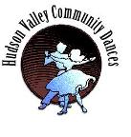

**English country Dance**

**~Dance Jane Austen's Dance~**

***First Saturday of Every Month***

**7:30 - 10:30 ~ Live band**

**music from the Baroque & present day**

**7:00 PM - Introductory class. Beginners welcome!**

***No partner needed, all dances taught***

**Bring water, soft-soled clean shoes....and a smile**

**~ at our usual venue ~**

**Reformed Church Salem Street, Port Ewen**

**Parking on Hasbrouck Ave**

***live music from Tiddly Pom***

**Contact: Lindsay 845-475-2530, Lindsay.morgan417@gmail.com**

